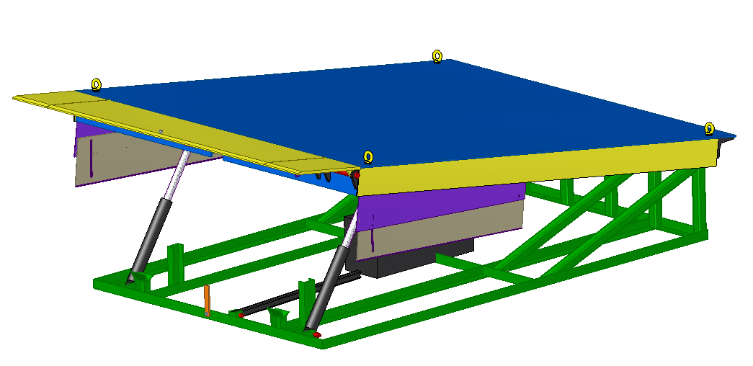

System Manual

Project No. | PR2016000007
Project Name | DOCK LEVELLER
Sub-Project | DOCK LEVELLER-15 TON
Customer | NIHVA

System Identification

Project Code | PR2016000007
Project Name | DOCK LEVELLER
Manufacturer
Office Address
Factory Address
Telephone No.
Email Address for Service
Website
GA Drawing No.
  PR2016007001
Customer PO No.
Project Dispatch Month & Year | SEP 2016
Customer Name | NIHVA

Table 1: Identification Data

Foreword

We are pleased to forward this manual to you to provide guidelines on trouble free operation of the equipment, procedures for periodic and preventive maintenance, and troubleshooting. This manual consists of the description of equipment along with technical specifications, and operation procedures. For maintenance of ‘Bought-out’ equipment, please refer manufacturers’ manuals. We insist you to maintain necessary record (logbook) for ensuring proper preventive maintenance, to achieve trouble free production. We are sure; you will find this manual very useful and interesting. However, your suggestions and doubts if any are always welcome!

Manual Revision History

Print Date | Manual Type | Prepared By | Revision | Remark
22 November 2026 | System Manual | KETAN | First Copy

Table of Contents
1. System Identification 2
2. Table of Contents 4
3. System Description 5
3.1 Major Unit Description 6
3.1.1 Bottom Frame Unit 7
3.1.2 Top frame Unit 8
3.1.3 Hyd Cyl Unit-1 9
3.1.4 Hyd Cyl Unit-2 10
3.1.5 Lip Unit 11
3.1.6 Manual stopper Unit 12
4. Maintenance & Troubleshooting 13
4.1 Safety Precautions - Dos and Don’ts 13
4.1.1 Do's of the system 13
4.1.2 Don’ts of the system 13
4.2 Preventive Maintenance 14
4.2.1 Hydraulic Circuit of the machine 14
4.2.2 Hardware 15
4.2.3 Lubrication 15
4.2.4 Hydraulic System Components 15
5. Spare & Wear Part Lists 16
5.1 Mechanical Critical Bought-out Parts 16
5.2. Mechanical Wear Parts 16
6. Appendix 18
6.1 Appendix 1 – Assembly & Wear Parts Drawings 18

Table of Figures

Figure 1: General Arrangement of system 5
Figure 1.1: Over all Dimension views 6
Figure 2: Bottom Frame Unit 7
Figure 3: Top Frame Unit 8
Figure 4 : Hyd Cyl Unit-1 9
Figure 5: Hyd Cyl Unit-2 10
Figure 6: Lip Unit 11
Figure 7: Manual Stopper Unit 12

3.System Description

Shows the general layout of the system and its major parts.
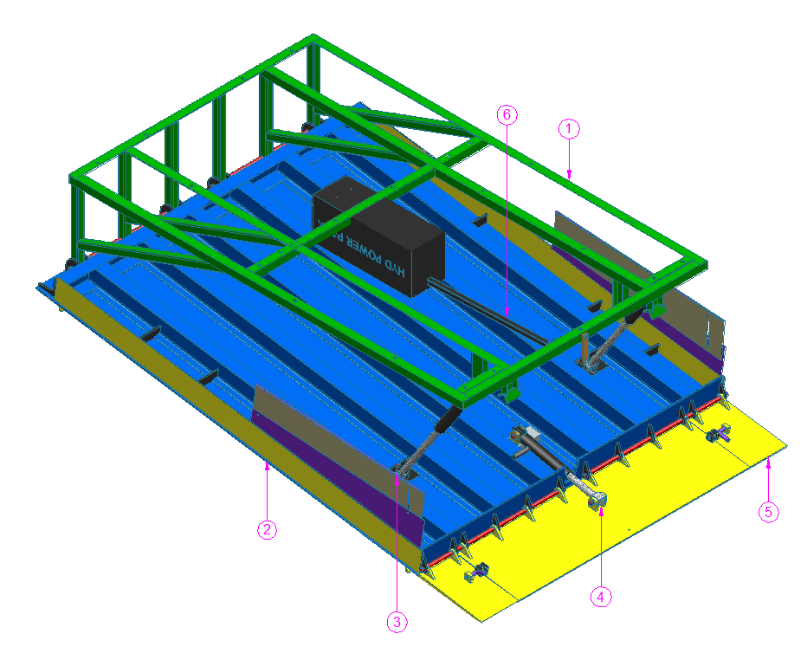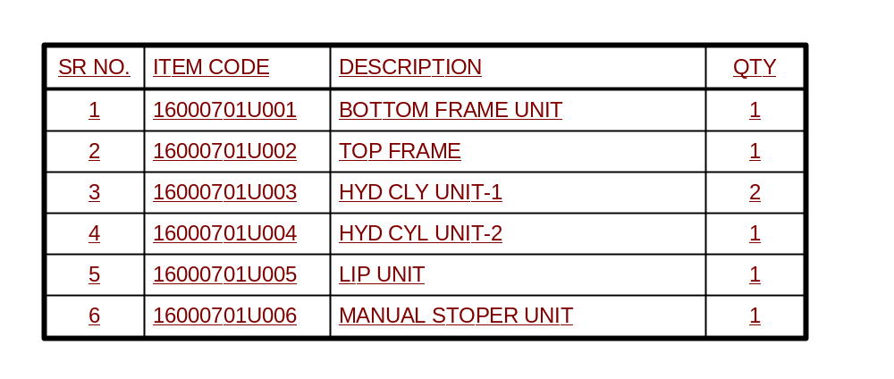
Figure 1: General Arrangement of system

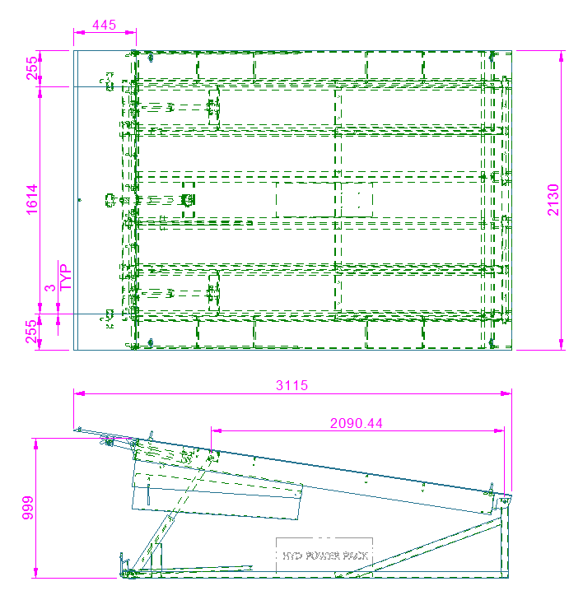

Figure 2: Over all Dimensions views.

3.1 Major Unit Description

3.1.1 Bottom Frame Unit
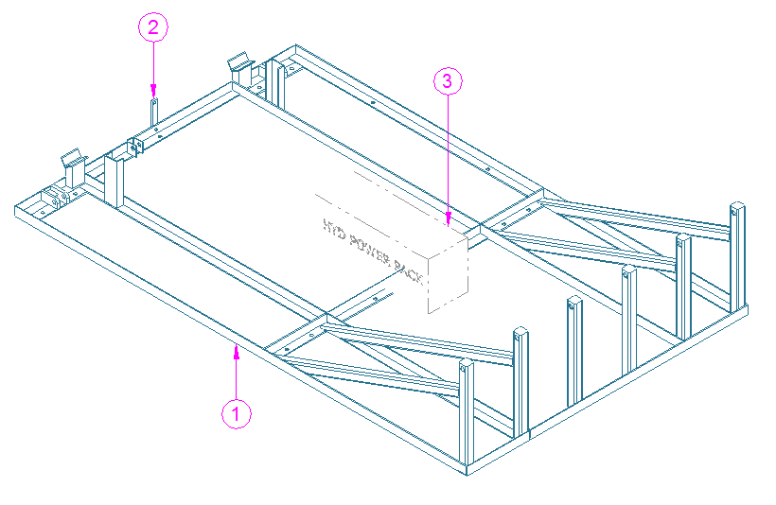
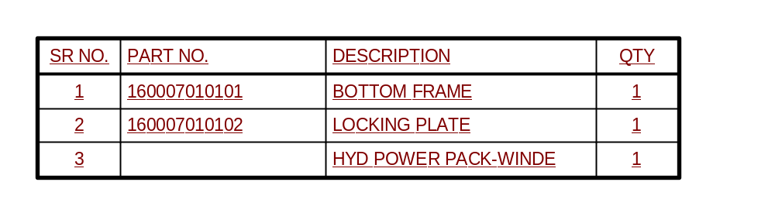

Figure 2: Bottom Frame Unit

3.1.2 Top Frame Unit
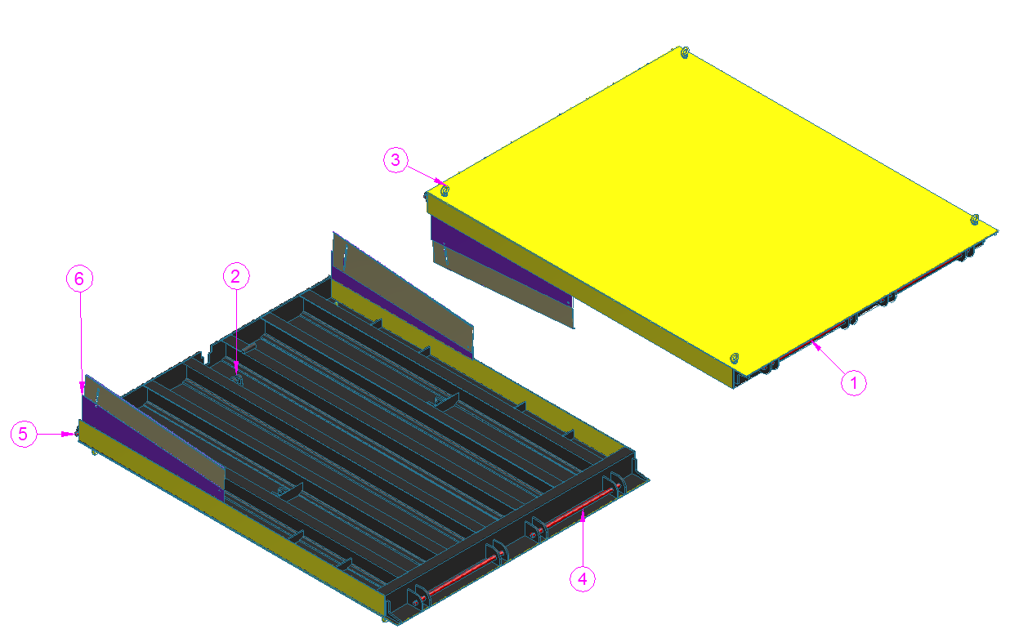

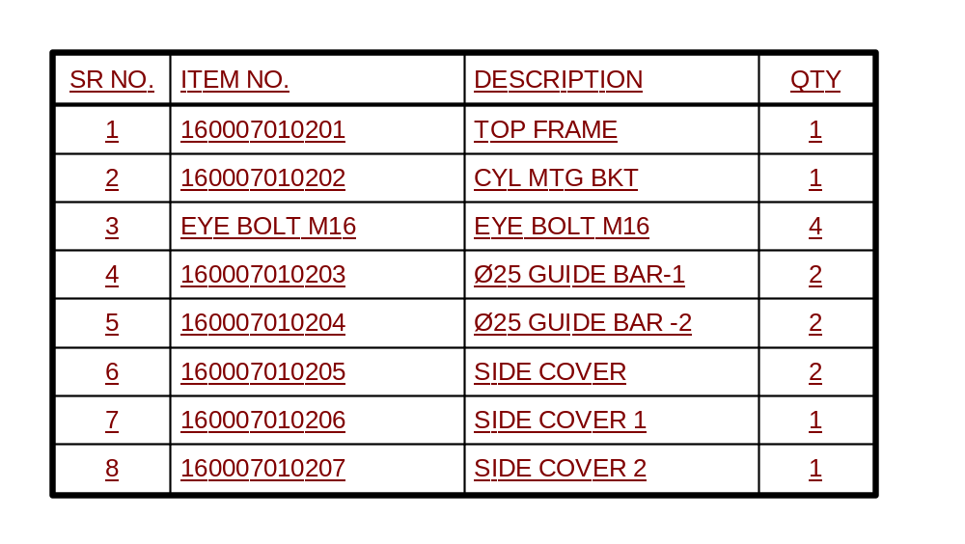

Figure 3: Top Frame Unit

3.1.3 HYD CYL UNIT -1

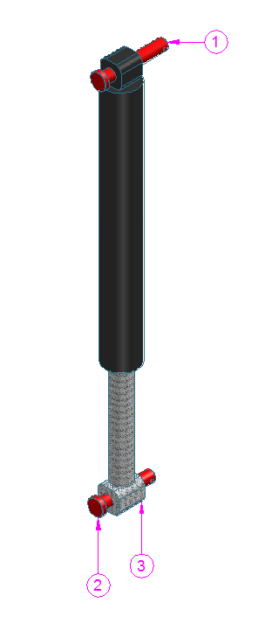

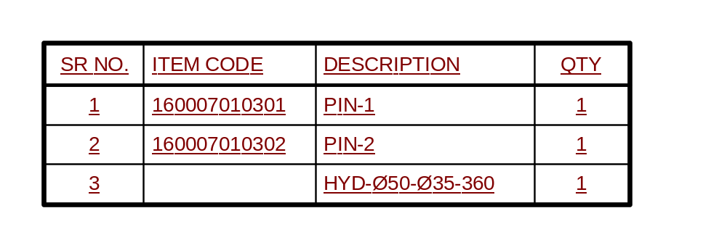

Figure 4 : HYD CYL UNIT-1

3.1.4 HYD CYL UNIT -2
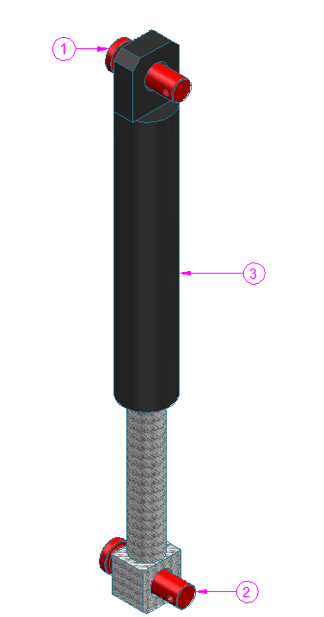

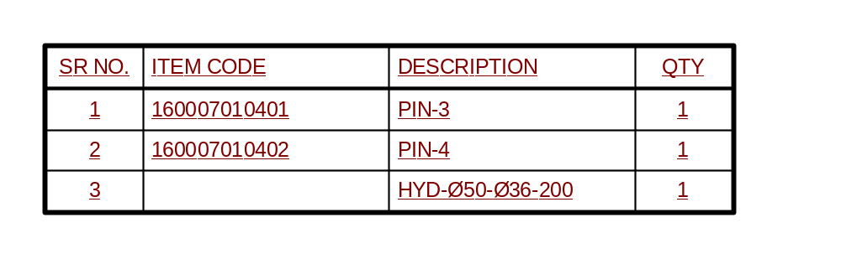

Figure 5: HYD CYL UNIT-2

3.1.5 Lip Unit
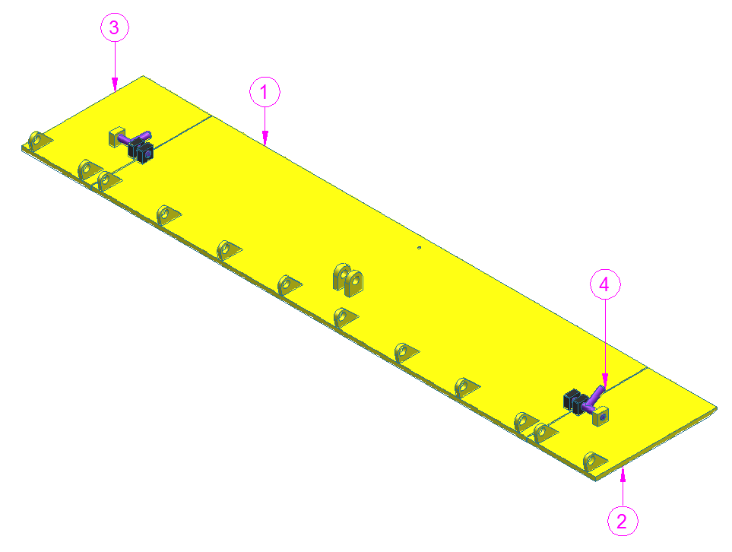

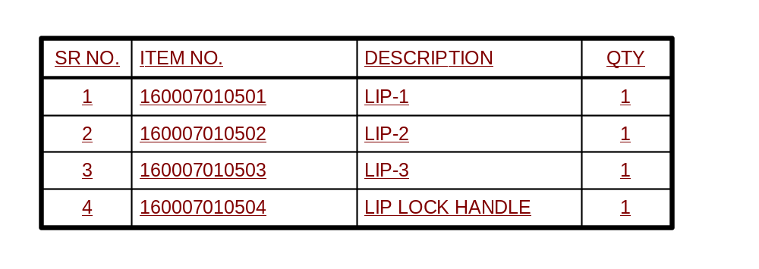

Figure 6: Lip Unit

3.1.6 Manual Stopper Unit

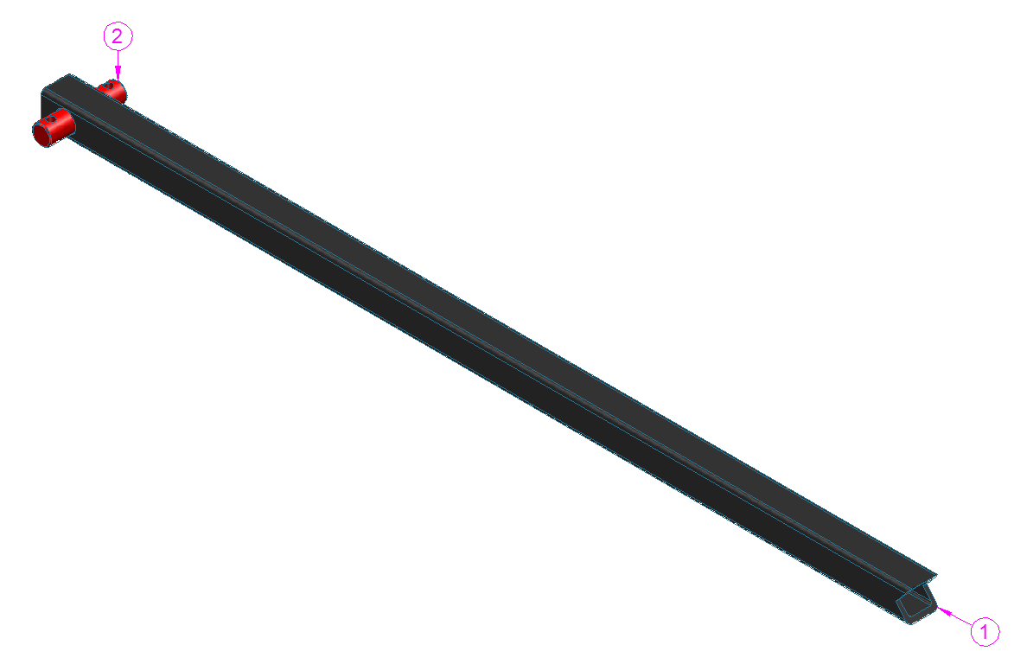

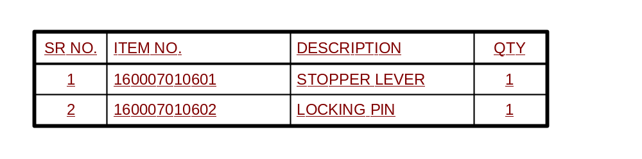

Figure 7: Manual Stopper Unit

4. Maintenance & Troubleshooting

4.1 Safety Precautions - Dos and Don’ts

4.1.1 Do's of the system
- Power is switched off before entering into the Machine area for setting or maintenance.
- Press any E-Stop button (A red push button) and then follow the internal procedures of your company or organization for an emergency situation. Do not disconnect the power or Hydraulic supply to the system unless you are sure that nobody is trapped near the system. The E-Stop button is provided on Operator consol.
- Always ensure that system is” Switched off” while entering cell for maintenance or other activities.
- Use safety equipment’s like hand gloves etc.
- Use proper tools for the setting & maintenance activities.
- Clean the oil, dust & unwanted raw materials in the machine area after maintenance.

4.1.2 Don’ts of the system
- Do not set the system movements / programming with high speed.
- Do not bypass the limit switches of machines.
- Do not change the positions of the limit switches & dogs.
- Do not remove any covers.
- Do not lose the clamping screws on couplings, etc.
- Do not enter the machine when Auto cycle is ON.
- Do not alter the settings in the system.
- Do not put your hand while movement of torch slides while it is operating in given direction.
- Do not go away from the machine when machine is running.
 | – Note –  - Always maintain necessary logbooks for proper maintenance and Troubleshooting for trouble free production.

4.2 Preventive Maintenance
The importance of preventive maintenance cannot be over emphasized. Preventive maintenance will enable the machine to give long and trouble free service.

4.2.1 Hydraulic Circuit of the machine
Sr. No. | Activity | Action | Daily | Weekly | Monthly | Half Yearly | Yearly | Remarks
 | Oil | Check
 | Oil Leakage | Check and Take Corrective Action
 | Hydraulic Pressure Switch | Check / Replace
 | Oil Filter | Clean / Replace Cartridge *
Table 2: Preventive Maintenance for Hydraulics.

4.2.2 Hardware
S. N. | Activity | Action | Daily | Weekly | Monthly | Half Yearly | Yearly | Remarks
 | Tightening of Nuts on Piston Rod | Check / Tighten
 | Sensors Sensitivity and Mounting | Check / Replace / Correct
 | a) Foundation Bolts / Leveling Bolts | Check / Tighten
 | b) All Hardware Tightening | Check / Tighten
 | All parts in contact with the component (e.g. Resting blocks, Locating pins and Clamping pads.) | Check and replace
Table 3: Preventive Maintenance for Hardware

4.2.3 Lubrication
Sr. No. | Activity | Action | Daily | Weekly | Monthly | Half Yearly | Yearly | Remarks
 | Oiling of all moving joints | Check
Table 4: Preventive Maintenance for Lubrication

4.2.4 Hydraulic System Components
Subsystem | Observation | Cause | Solution
Hydraulic fittings. | Oil leakage. | Joints or cracked tubes.  Loose fitting. | Check and replace tubes or other Hydraulic fittings.  Proper fitting of all connectors.
Hydraulic  cylinder. | Stroke of  The cylinder insufficient. | Oil pressure low. | Adjust pressure setting.
Hydraulic  cylinder. | Stroke of  The cylinder insufficient. | Oil leakage. | Check the Hydraulic circuit and Hydraulic fittings.
Hydraulic  cylinder. | Stroke of  The cylinder insufficient. | Mounting arrangement not proper. | Do the correct mounting arrangement.
Solenoid operated valve | Cylinder not actuating. | Solenoid coil failure. | Replace the valve. Check the valve operation using manual override button on the valve.
Solenoid operated valve | Cylinder not actuating. | Electrical supply to valve is not correct. | Check the electrical supply.
Solenoid operated valve | Cylinder not actuating. | Hydraulic supply failure  Solenoid failure due to sticky spool movement. | Check the hydraulic supply. Sometimes cleaning the valve assembly does help. However, this is a delicate and skilled job.
Flow Control Valve | Cylinder speed cannot be controlled satisfactorily | Flow control valve setting wrong. | Set the FCV correctly. Note that most of the Flow Control implementations are generally “Meter Out”. In case of clamping application, the flow control implementations are “Meter In”.
Flow Control Valve | Cylinder speed cannot be controlled satisfactorily | Dust, dirt in the valve in the Hydraulic circuit. | Clean the FCV regularly.
Flow Control Valve | Oil leakage from FCV | Breakage of FCV | If defective then replace it.
Table 5: Hydraulic faults & Troubleshooting. If a fault cannot be cured or if there is a serious mechanical or electrical failure, you should contact your nearest dealer or contact

Spare & Wear Part Lists

5.1 Mechanical Critical Bought-out Parts

S NO | ITEM DESCRIPTION | QTY. | UNITS
1 | HYD-Ø50-Ø35-360 | 2
2 | HYD-Ø50-Ø36-200 | 1
Table 6: Mechanical Critical Bought-out Parts

5.2. Mechanical Wear Parts

Sr. No. | Units / Part code | Units / Part Description | Qty.
1 | 160007010301 | PIN-1 | 1
2 | 160007010302 | PIN-2 | 1
3 | 160007010401 | PIN-3 | 2
4 | 160007010402 | PIN-4 | 1

Table 7: Mechanical Wear Parts

Appendix

Refer all contained documents in appendix are added separately after this page.

6.1 Appendix 1 – Assembly & Wear Parts Drawings
This appendix of manual contains Units Assembly Drawings & its wear part drawings.
S.N. | Assembly Drawing No. | Description | QTY
 | PR2016007001 | DOCK LEVELLER -15 TON | 1

- Appendix 1 -
MECHANICAL ASSLY DRAWING

Project No. | PR2016000007
Project Name | DOCK LEVELLER
Sub-Project | DOCK LEVELLER -15 TON
Customer | NIHVA

